#### PROSTHETIC ARM

**A mini project report submitted in partial fulfillment of the requirement for the award of the degree of**

**Bachelor of Technology In**

**ELECTRONICS AND COMMUNICATION ENGINEERING BY**

#### J.HARSHA VARDHAN : 22L31A0568

#### J .JAYANTH : 22L31A0570

**K.JASWANTH : 22L31A0577**

#### L .N .SURYA KIRAN : 22L31A05B2

#### L.P.S.PARDHU : 22L31A05B3

Under the Esteemed Guidance of Project guide

**Dr. Susant Kumar Sahu**

Associate Professor

Department Of Mechanical Engineering Vignan’s Institute Of Information Technology

**Mrs. B. Bharni** Assistant Professor Department Of CEER

Vignan’s Institute Of Information Technology



**DepartmentofElectronicsandCommunicationEngineering Vignan’s Institute of Information Technology (A) Visakhapatnam-530049 INDIA 2020-2024**



**Department Of CEER**

**VIGNAN’S INSTITUTE OF INFORMATION TECHNOLOGY**

**VISAKHAPATANAM**

**(Autonomous)**

**(Approved by AICTE, New Delhi, Accredited by NBA, Affiliated to Jawaharlal Nehru Technological University, Kakinada)**

**Besides VSEZ, Duvvada, Vadlapudi post, Gajuwaka Visakhapatanam – 530049, A.P., India.**

**2021 - 2022**

**PROSTHETIC ARM**

**Department of COMPUTER SCIENCE AND Engineering Vignan’s Institute of Information Technology (A)**



**Certificate**

This is to certify that the project entitled **“PROSTHETIC ARM”** submitted by J.HARSHAVARDHAN(22L31A0568),J.JAYANTH(22L31A0570),K.JASWANTH(22L31A0577),L.N.SURYAKIRAN(22L31A05B2),L.P.S.PARDHU(22L31A05B3) in fulfillment of the requirement for the award of B.Tech Degree in COMPUTER SCIENCE and ENGINEERING, is a Bonafide project work carried out by them under the guidance and supervision in the Department of Electronics and Communication Engineering, Vignan’s Institute of Information Technology, Visakhapatnam. This work has not been submitted to any university for award of any degree.

**Project Guide Head of the Department**

**Mrs. B. Bharni**

Assistant Professor Department of Electrical and Communication Engineering, VIGNAN INSTITUTE OF

INFORMATION TECHNOLOGY(A),

Visakhapatnam, India.

**Dr. CH. V. V. Ramana** Head of Department Department of CEER, VIGNAN INSTITUTE OF

INFORMATION TECHNOLOGY(A),

Visakhapatnam, India.

**DECLARATION**

We hereby declare that the mini project entitled **“PROSTHETIC ARM”** been written by us and has not been submitted either in part or whole for the award of any degree, diploma or any other similar title to this or any other university.

**Date: 26-02-2023**

#### Acknowledgement

We would like to express our gratitude to **Mrs. B. Bharni ,** Associate professor, Department of Electronics and Communication Engineering, for her valuable guidance, advice and supporting us in successfully doing this project.

We would like to express our heartful thanks to Dr. CH.V.V. RAMANA, head of the department of the CEER department, Vignan’s Institute Of Information Technology (Autonomous) for creating facilities for carrying on this project work.

We express our sincere thanks to **Dr. B. ARUNDATI** , Principal, VIGNAN INSTITUTE OF INFORMATION TECHNOLOGY , Visakhapatnam for her co-operation and encouragement on this project.

We express our sincere thanks to **Dr . V .MADHUSUDHAN RAO** , Rector **, Mr. B**. **SRIKANTH** , Executive Director, VIGNAN VIZAG GROUP , Visakhapatnam for their Valuable suggestions and encouragement for completion of this project.

Lastly, we extend our gratitude to all our Teaching and Non-Teaching staff and all my friends, who directly or indirectly helped us in this Endeavour.

**Regards**

**J.HARSHA VARDHAN 21L31A0568**

**J.JAYANTH 22L31A0570**

**K.JASWANTH 22L31A0577**

**L.N.SURYAKIRAN 22L31A05B2**

**L.P.S.PARDHU 22L31A05B3**

#### ABSTRACT

#### CONTENTS

|  |  |  |  |
| --- | --- | --- | --- |
| **S.NO**. | **CONTENT NAME** |  | |
|  |  |  | |
| **CHAPTER 1 –INTRODUCTION** | | | |
| 1.1 | INTRODUCTION | | 7 |
| 1.2 | PROBLEM STATEMENT | | 8 |
| 1.3 | OBJECTIVE | | 8 |
| 1.4 | METHODOLOGY | | 9 |
| 1.5 | SCOPE OF WORK | | 9 |
| **CHAPTER 2 –DESCRIPTION** | | | |
| 2.1 | COMPONENTS | | 11 |
| 2.2 | CIRCUIT DIAGRAM | | 17 |
| 2.3 | WORKING | | 17 |
| 2.4 | CODE | | 18 |
| 2.5 | APPLICATIONS | | 24 |
| **CHAPTER 3 –RESULT** | | | |
| 3.1 | ARDUINO CAR PARKING SYSTEM | | 25 |
| 3.2 | CONCLUSION | | 26 |
| 3.3 | FUTURE ENHANCEMENT | | 26 |
| 3.4 | REFERENCES | |  |

Department of ECE, VIIT (A)

Page 7

.

# CHAPTER -1

Department of ECE, VIIT(A) Page 8

**INTRODUCTION**

#### INTRODUCTION

In the recent years, a large number of new registered vehicles were reported compared to the previous years, which makes it a rough estimate of 54.5% increase in a span of 7 years (Malaysian Ministry of Transportation, 2007). Referring to the aforesaid statistics provided by the Malaysian Ministry of Transportation, the current transportation infrastructure and car park facilities are deemed insufficient in sustaining the influx of vehicles on the road. Therefore, problems such as traffic congestion and insufficient parking space inevitably crops up. In Asia, the situation are made worse by the fact that the roads are significantly narrower compared to the West (Inaba et al., 2001). Various measures have been taken in the attempt to overcome the traffic problems. Although, the problem can be addressed via many methods, the paper focuses on the car park management system introduced, which is the smart parking system. This study will review the evolution of vehicle detection technologies as well as the detection systems developed over the years.

Department of ECE, VIIT (A)

Page 9

its deployment in the car park, it is hoped that it would solve the aforementioned problems faced by the patrons within the car park.

* 1. Advantages of smart parking system implementation:

The smart parking system is considered beneficial for the car park operators, car park patrons as well as in environment conservation. . For the car park operators, the information gathered via the implementation of the Smart Parking System can be exploited to predict future parking patterns. Pricing strategies can also be manipulated according to the information obtained to increase the company’s profit. In terms of environment conservation, the level of pollution can be reduced by decreasing vehicle emission (air pollutant) in the air . This can be attributed to the fact that vehicle travel is reduced. As fuel consumption is directly related.

Patrons are also able to benefit from smart parking system as parking space are able to be fully utilized optimized and more efficient system implemented. The system is made more efficient as vehicle travel time and search time are significantly reduced due to the information provided by car parking system.

## Disadvantages of a Parking Management System

## 

The cost of having a sound, working parking management system is usually high. This is because of the various components that go into making the system work. Components such as the statistical feature, automated ticketing, and statistical reports, and many others make it all expensive. Some organizations may not be able to afford such.

* 1. Aim of the Work:

The purpose of the project is to reduce the number of workers in the garage and reduce the prevalence of owners of cars because there is in the 7-meter counter at the entry of the car has a count down. While, when the exit is counting ascending or according to what is mentioned or written within the programming of Arduino and determine the absorption of the garage number of vehicles through the owner. When the highest value of the meter, the door of the garage is closed electronically and cannot be opened until the exit of one of the cars and this project can be added by several devices that help the person to gain time and reduce the congestion caused by protrusion such as the depletion of Gps.

# CHAPTER-2

**ARDUINO CAR PARKING SYSTEM**

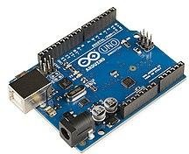

**DESCRIPTION**

#### COMPONENTS

* ARDUINO UNO BOARD
* BREAD BOARD
* SERVO MOTOR
* JUMPER WIRES
* EMG SENSOR

#### ARDUINO UNO BOARD

The Arduino Uno is an open-source microcontroller board based on the Microchip ATmega328P microcontroller and developed by Arduino.cc. The board is equipped with sets of digital and analog input/output (I/O) pins that may be interfaced to various expansion boards (shields) and other circuits. The board has 14 digital I/O pins (six capable of PWM output), 6 analog I/O pins, and is programmable with the Arduino IDE (Integrated Development Environment), via a type B USB cable.

Figure 2.1.1 Arduino uno board

Department of ECE, VIIT(A)

Page 13

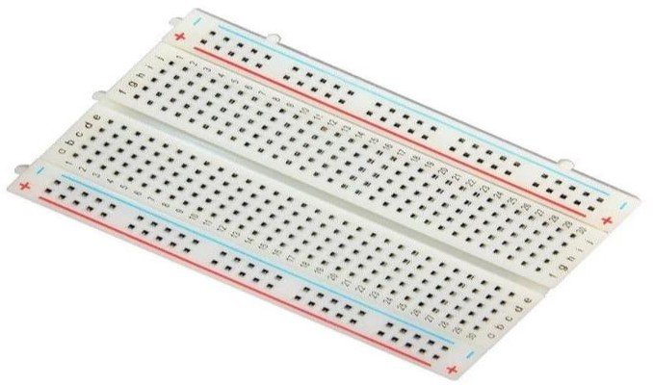

#### BREADBOARD

An electronics breadboard (as opposed to the type on which sandwiches are made) is actually referring to a solderless breadboard. These are great units for making temporary circuits and prototyping, and they require absolutely no soldering . Prototyping is the process of testing out an idea by creating a preliminary model from which other forms are developed or copied, and it is one of the most common uses for breadboards. If you aren’t sure how a circuit will react under a given set of parameters, it’s best to build a prototype and test it out.

### Figure 2.1.2 Breadboard

#### SERVO MOTOR

A **servomotor** (or **servo motor**) is a [rotary actuator](https://en.wikipedia.org/wiki/Rotary_actuator) or [linear actuator](https://en.wikipedia.org/wiki/Linear_actuator) that allows for precise control of angular or linear position, velocity and acceleration. It consists of a suitable motor coupled to a sensor for position feedback. It also requires a relatively sophisticated controller, often a dedicated module designed specifically for use with servomotors.

Servomotors are not a specific class of motor, although the term *servomotor*is often used to refer to a motor suitable for use in a [closed-loop control](https://en.wikipedia.org/wiki/Closed-loop_control) system.

Servomotors are used in applications such as [robotics](https://en.wikipedia.org/wiki/Robotics), [CNC machinery](https://en.wikipedia.org/wiki/CNC_machine), and [automated manufacturing](https://en.wikipedia.org/wiki/Automated_manufacturing)**.**

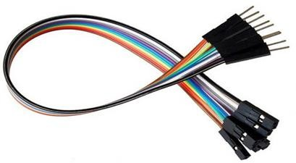

#### JUMPER WIRES

A jump wire (also known as jumper, jumper wire, jumper cable, DuPont wire or cable) is an electrical wire, or group of them in a cable, with a connector or pin at each end (or sometimes without them – simply "tinned"), which is normally used to interconnect the components of a breadboard or other prototype or test circuit, internally or with other equipment or components, without soldering .Individual jump wires are fitted by inserting their "end connectors" into the slots provided in a breadboard, the header connector of a circuit board, or a piece of test equipment.

### Figure 2.1.4 J

2.15 EMG SENSOR

#### 

An EMG (Electromyography) sensor is a device used to measure and record the electrical activity of muscles. This type of sensor detects the electrical signals generated by muscle cells, which are called motor units, as they contract and relax.

EMG sensors are commonly used in various applications such as medical diagnosis, physical therapy, and sports performance analysis. In medical diagnosis, EMG sensors can be used to detect and diagnose neuromuscular disorders, such as carpal tunnel syndrome, ALS, and muscular dystrophy. In physical

therapy, EMG sensors can be used to help patients with muscle rehabilitation by measuring their muscle activity and providing feedback to them or their therapist.

#### 

#### 2.16 CIRCUIT DIAGRAM

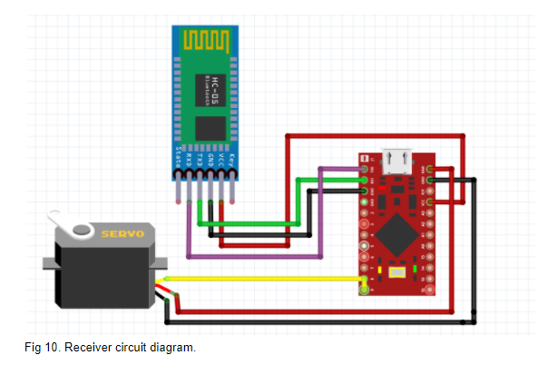

CODE

//Include Servo library

#include <Servo.h>

//Declare EMG sensor input pins

const int EMG1 = A0; //Thumb

const int EMG2 = A1; //Index Finger

const int EMG3 = A2; //Middle Finger

const int EMG4 = A3; //Ring Finger

const int EMG5 = A4; //Little Finger

//Declare Servo motor output pins

const int thumbPin = 2;

const int indexPin = 3;

const int middlePin = 4;

const int ringPin = 5;

const int littlePin = 6;

//Create Servo objects for each finger

Servo thumb;

Servo index;

Servo middle;

Servo ring;

Servo little;

//Declare variables for EMG sensor readings

int emg1Value;

int emg2Value;

int emg3Value;

int emg4Value;

int emg5Value;

//Declare variables for Servo motor positions

int thumbPos;

int indexPos;

int middlePos;

int ringPos;

int littlePos;

void setup() {

//Initialize Servo objects and attach to output pins

thumb.attach(thumbPin);

index.attach(indexPin);

middle.attach(middlePin);

ring.attach(ringPin);

little.attach(littlePin);

//Initialize serial communication

Serial.begin(9600);

}

void loop() {

//Read EMG sensor values

emg1Value = analogRead(EMG1);

emg2Value = analogRead(EMG2);

emg3Value = analogRead(EMG3);

emg4Value = analogRead(EMG4);

emg5Value = analogRead(EMG5);

//Map EMG sensor values to Servo motor positions

thumbPos = map(emg1Value, 0, 1023, 0, 180);

indexPos = map(emg2Value, 0, 1023, 0, 180);

middlePos = map(emg3Value, 0, 1023, 0, 180);

ringPos = map(emg4Value, 0, 1023, 0, 180);

littlePos = map(emg5Value, 0, 1023, 0, 180);

//Move Servo motors to the mapped positions

thumb.write(thumbPos);

index.write(indexPos);

middle.write(middlePos);

ring.write(ringPos);

little.write(littlePos);

//Print EMG sensor values and Servo motor positions to serial monitor

Serial.print("EMG1: ");

Serial.print(emg1Value);

Serial.print(" EMG2: ");

Serial.print(emg2Value);

Serial.print(" EMG3: ");

Serial.print(emg3Value);

Serial.print(" EMG4: ");

Serial.print(emg4Value);

Serial.print(" EMG5: ");

Serial.print(emg5Value);

Serial.print(" Thumb: ");

Serial.print(thumbPos);

Serial.print(" Index: ");

Serial.print(indexPos);

Serial.print(" Middle: ");

Serial.print(middlePos);

Serial.print(" Ring: ");

Serial.print(ringPos);

Serial.print(" Little: ");

Serial

# CHAPTER-3

PROSTHETIC ARM

## RESULT

PRPOSTHETIC ARM

CONCLUSION

**THANK YOU**